
Year 5 Overview of Spring Term
 | Spring 1 | Spring 2 |  |  | Spring 1 | Spring 2
 |  |  |  | History |  | Ancient Greece
Visits, visitors and experiences | Hindleap Warren Residential  Victorian Workshop | Science Week  World Book Day  Mills Farm |  | Geography | Digimaps
English | 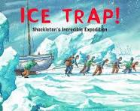  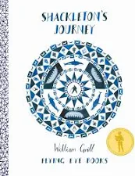 | 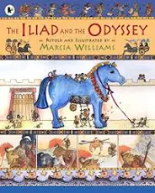 |  | Design and Technology | Pop-Up Books | Greek Vases
Whole Class Reading | 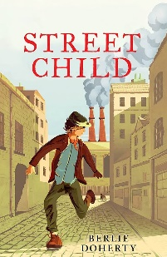 | 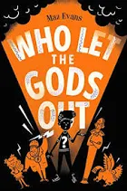 |  | Music | Music from South and West Africa | Composition to represent the festival of colour
Maths | Multiplication and division  Fractions | Decimals and Percentages  Perimeter and Area  Statistics |  | Art | Portraits
Science | Forces | Science Week  Caring for our World |  | RE | Humanism | Buddhism
Computing | iCrypto  iModel | iWeb |  | PSHE | How can we help in an accident or emergency? | What jobs would we like?
PE | Fitness  Gymnastics | Handball  Golf |  | MfL | Shopping | Space exploration

