
Year 2 Overview of Spring Term
 | Spring 1 | Spring 2 |  |  | Spring 1 | Spring 2
Big question | How do animals and humans survive in different environments? | How has space exploration influenced and improved our daily lives? |  | History | N/A | Explorers –  The Space Race
Visits, visitors and experiences |  | Winchester Science Centre |  | Geography | Polar Explorers | N/A
English | 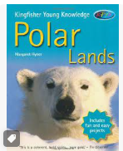  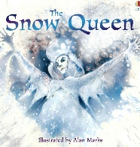  Story Writing Information Texts | 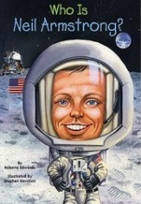  What is a Biography?  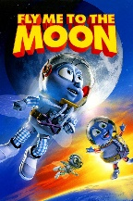  Recount Writing |  | Design and Technology | Mechanisms –  Moving Monster | N/A
Whole Class Reading | Little Wandle Letters and Sounds | Little Wandle Letters and Sounds |  | Music | Kapow  Dynamics, timbre, tempo and motifs (Theme: Space) | Kapow  Musical me
Maths | Geometry  Money | Multiplication and Division |  | Art | N/A | Painting/Craft – Map it out  Jospef Albers, Eduardo Paolozzi
Science | Habitats | Plants and Seeds |  | RE | Learning about different faiths - Islam | Why does Easter Matter to Christians? Understand how Christians celebrate Holy week.
Computing | IAnimate | IPublish |  | PSHE | What is Bullying? | What Jobs Do People Do?
PE | Yoga | Target Games |  | MfL | French | French

