Traditional tales with a link to Understanding the world (Where am I?)
Prime Areas

Area of learning | Objectives/skills | Revisit/ongoing  throughout the year | Suggested texts, songs and rhymes
Communication and Language   | Listening:  Listen in familiar and new situations.  Engage in stories that are familiar and new with interest and enjoyment.  Attention:  Maintain attention in new situations e.g., whole school assembly or PE sessions in the hall.  Shift attention when required e.g., when given a clear prompt - ‘name’.  Respond:  Make relevant comments when listening to a story and can answer ‘why’ questions.  Link events in a story to their own experiences.  Ask questions to find out more and to check they understand what has been said to them.  Respond to others appropriately in play.  Engage in story times.  Engage in non-fiction book.  Understanding:  Follow instructions or a question with 2 or more parts.  Speaking:  Use intonation to make meaning clear to others.  Start a conversation with peers and familiar adults and continue it for many turns.  Use simple conjunctions in talk to link thoughts ‘and’ ‘because’.  Retell a simple event e.g., how scratched knee’ Recognise words that rhyme or sound similar E.g., “Cat and hat”.  Develop social phrases – “Good morning, how are you?” | Learn new vocabulary Use new vocabulary in different contexts.  Use new vocabulary through the day in discussions and conversations.  Learn new rhymes, poems, and songs.  Listen to and talk about stories to build familiarity and understanding. | Traditional tales and alternative versions of them.  Children use the core books to develop story language. (see literacy section)  Children begin telling their own stories using relevant vocabulary.
Personal, Social  and Emotional Development   | Express feelings:  Can show concern for others and show awareness of how their actions may impact on others.  Can identify how they are feeling on the zone of regulation board.  Beginning to express their feelings and consider the perspectives of others.  Manage behaviour:  Begin to take turns and share resources.  Can usually tolerate delay when needs are not immediately met.  Self-awareness:  Can talk about what they are doing and why.  Independence:  Can independently choose areas they would like to play in or resources they would like to use.  Can say when they need help.  Become more independent when dressing and undressing- in particular coats and jumpers.  Can follow instructions with 2 or more parts.  Collaboration:  Begin to share and take turns.  Social skills:  Continue to build constructive and respectful relationships.  Seek familiar adults and peers to engage in conversations and ask for help. | Continue to develop skills of using gestures, non-verbal communication, facial expressions, body language, appropriate language, and vocabulary; to listen to others, speak to peers and adults and engage in discussions in a positive way.  Use zones of regulation  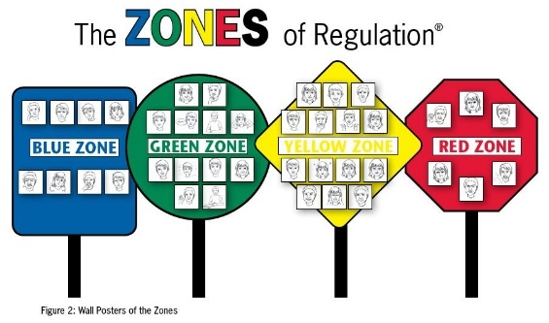 | Children use the core books to explore different aspects of the world. (see literacy section)  E.g., Growing, right and wrong, keeping safe, teamwork.

Physical  Development   | Continue to develop the skills they need to manage the school day successfully: lining up and queuing, transitions, mealtimes, personal hygiene.  Children begin to show precision in the marks they make. Develop their small motor skills so that they can use a range of tools competently, safely, and confidently. Suggested tools: pencils for drawing and writing, paintbrushes, scissors, knives, forks, and spoon.  Gross motor skills – A-Frame (climbing), Outdoor Area (core strength), weekly PE lessons, tyres and large blocks for lifting. | Continue to develop overall body-strength, balance, co-ordination, and agility through use of outdoor play equipment.  Develop fine motor in preparation for pencil control.  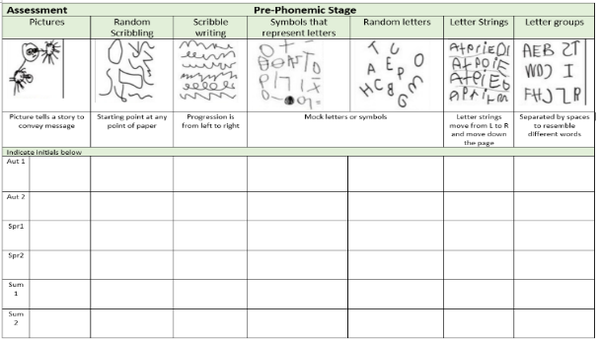
Develop the overall body strength, co-ordination, balance, and agility needed to engage successfully with future physical education sessions and other physical disciplines including dance, gymnastics and athletics.
Revise and refine the fundamental movement skills they have already acquired: rolling, crawling, walking, jumping, running, hopping, skipping, climbing.
Specific Areas
Literacy   | COMPREHENSION  Experience and respond to different types of books, e.g., story books, factual/real-world books, rhyming and non-rhyming stories, realistic and fantasy stories.  Respond to ‘who’, ‘where’ ‘what’ and ‘when’ questions linked to text and illustrations.  Make simple inferences to answer yes/no questions about characters' emotions in a familiar picture book read aloud to them.  Sequence two events from a familiar story, using puppets, pictures from book or role-play.  Begin to read with some prosody (expression) | Helicopter stories:  Children develop story structure with a beginning, middle and end. Children create their own story characters and a story line. Adults are dictated to by the child, the adult says each word as it is written, pointing out gaps and punctuation. The stories are acted out by their peers. | 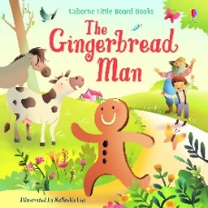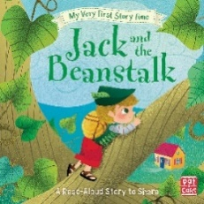  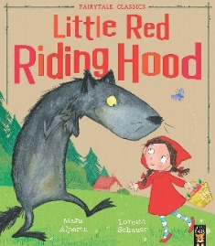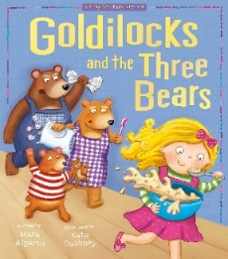  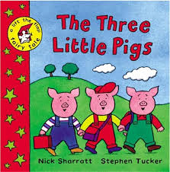  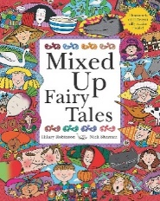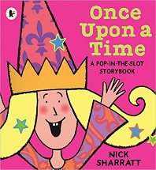  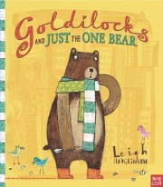Alternative versions.
 | WORD READING  Read individual letters by saying the sounds for them.  Blend sounds into words, so that they can read short words made up of known letter-sound correspondences.  Read a few common exception words matched to our phonic programme. | Re-read books to build up their confidence in word reading, their fluency and their understanding and enjoyment. Read books consistent with their phonic knowledge.
WRITING
Writing:
Copies adult writing behaviour e.g., writing on a whiteboard, writing messages.
Makes marks and drawings using increasing control.
Know there is a sound/symbol relationship.
Use some recognisable letters.
Write letters and strings, sometimes in clusters like words.
Child begins to write the initial sound of a word and the adult continues to write the other parts of the story.
Some children begin to re-read and scan to check their writing.
Composition:
Orally compose a sentence and hold it in memory before attempting to write it.
Spelling:
Orally spell CVC words by identifying the sounds.
Attempt phonically plausible words, some containing digraphs.
Write some tricky words correctly.
Write own name.
Phonics | Progress to Phase 3  Know grapheme phoneme correspondence of letters learnt.  Blend with known letters for reading VC and CVC words.  Orally segment for VC and CVC words for spelling.  Know high-frequency common words  Be able to orally blend simple words in their head.  Recognise digraphs as being 2 letters which make 1 sound.  Begin to know words which contain double letters (E.g. bb, mm, gg)  ‘Little Wandle Letters and Sounds’ Phonics programme – https://www.littlewandlelettersandsounds.org.uk/resources/ | 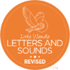  Continue to develop general sound discrimination, rhythm and rhyme, alliteration, voice sounds, oral blending, and segmenting.
Mathematics   | Following the structure of NCTEM | Develop confidence in using manipulatives, graphical representations, subitising and exploring pattern.  Counting real life objects, subitising and counting objects that are identical before moving onto objects with slight differences such as size or colour.  Children encouraged to put objects into a line when counting so there is a clear start and end point.  Five frames used to support and compare numbers within 5 and 10 frames used for numbers beyond.  Numerals introduced and children begin to write them.  Informal jottings/drawings to record thinking.  When counting continue to learn that the final number they say names the quantity of the set.  Continue to count, subitise and compare as they explore one more and one less. | 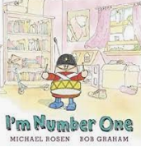  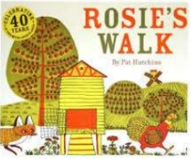  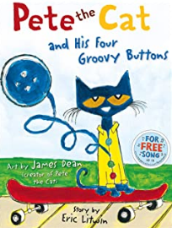
 | 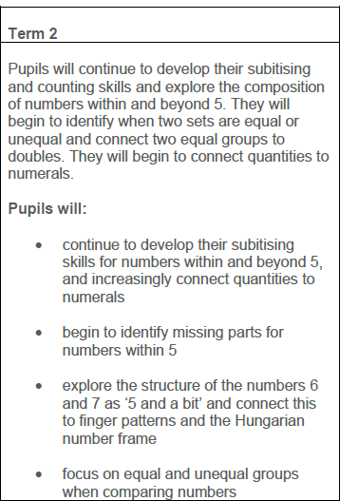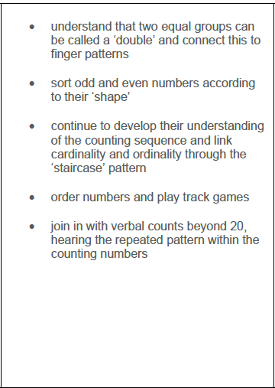
Understanding the World   | Chronology:  Use the language of time when talking about past/present events in their own lives and in the lives of others including people they have learnt about through books.  Enquiry:  Ask questions, use different sources to find answers including books.  Comment on images of familiar situations in the past and compare them to present.  Continue to develop a sense of continuity and change by being able to compare characters from stories.  Notice seasonal changes and explore what happens at times throughout the year.  Respect:  Recognise that people have different beliefs and celebrate special times in different ways.  To develop responsibility for our whole environment, including people, plants and animals.  Mapping:  Use technology e.g., a BeeBot and begin to show spatial awareness. Use positional language i.e., under, besides, on top of etc. Use Google Earth to find different countries where celebrations take place.  Exploring the difference between season around the world and in other countries. | Scientific skills –  Comment on what they notice about the environment where they live and understand the effect of the changing seasons on the natural world around them. Describe what they see, hear, and feel outside.  Observe, find out about and identify features of where we live and the natural world | Children use the core books to explore different aspects of the world. (see literacy section)  E.g., Growing, cooking, right and wrong, keeping safe, problem solving, sorting materials, food tastings, maps.
Expressive Arts and Design   | Develop storylines in their pretend play.  Sing in a group or on their own, increasingly matching the pitch and following the melody.  DT link - Exploring structures through sculpture and mixed media. | Explore, use, and refine a variety of artistic effects to express their ideas and feelings.  Explore and engage in music making and dance, performing solo or in groups.

