Where are we going and how will we get there? Adventure, both real and imaginary.
Prime Areas

Area of learning | Objectives/skills | Revisit/ongoing  throughout the year | Suggested texts, songs and rhymes
Communication and Language   | Listening:  Listen to and understand instructions about what they are doing, whilst busy with another task  Attention:  Listen and continue with an activity for a short time.  Respond:  Keep play going in response to the ideas of others and engage in conversation relevant to play theme.  Ask and answer ‘what’, ‘where’, ‘when’, and ‘what could we do next’ questions.  Listen to and talk about selected non-fiction to develop a deep familiarity with new knowledge and vocabulary.  Understanding:  Carry out a series of 3 directions. Show familiarity with selected non-fiction by using new knowledge and vocab in conversation and play. Understand ‘how’, ‘why’ and ‘where’ questions.  Speaking:  Recount an event in the correct order and some detail.  Give details that they know are important and will influence the listener E.g., “Ahmed fell over that stone, Javid didn’t push him”.  Express ideas about feelings and experiences.  Articulate their ideas in well-formed sentences.  Show that they can use language to reason and persuade E.g. “Can I go outside because it’s stopped raining?” | Learn new vocabulary Use new vocabulary in different contexts.  Use new vocabulary through the day in discussions and conversations.  Learn new rhymes, poems, and songs.  Listen to and talk about stories to build familiarity and understanding. | Children use the core books to develop language.  (see literacy section)  Children are introduced to new vocabulary through the Phonics teaching programme and encouraged to use the new words in a sentence.
Personal, Social  and Emotional Development   | Express feelings:  Initiate an apology where appropriate. Beginning to know that children think and respond in different ways to them.  Manage behaviour:  Can follow instructions, requests, and ideas in a range of situations.  Self-awareness:  Can talk about their own abilities positively.  Independence:  Confident to try new activities and say why they like some activities more than others.  Show resilience and perseverance, a belief that with more effort or with a different approach success will occur.  Understands rules linked to road safety.  Can follow directions with 3 parts.  Collaboration:  Know it is important for all of us to keep safe when using and transporting tools, equipment, and resources.  Social skills:  Can be considerate to the needs of others, beginning to respect a different point of view and work together in collaboration.  Children are able to manage change in routine and environment in preparation for transition into Year 1. | Continue to develop skills of using gestures, non-verbal communication, facial expressions, body language, appropriate language, and vocabulary; to listen to others, speak to peers and adults and engage in discussions in a positive way.  Children have become increasingly confident in using the ‘Zones of regulation’ the identify how they are feeling at certain moments.  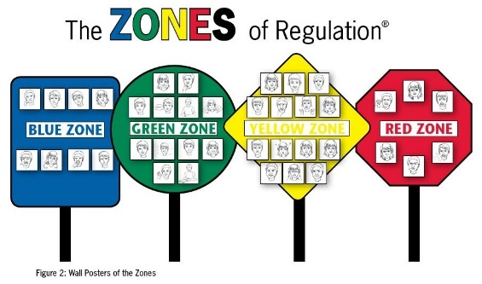 | Children use the core books to explore different aspects of the world. (see literacy section)  Books to support children as they prepare for the transition into Year 1.

Physical  Development   | Develop the foundations of a handwriting style which is fast, accurate and efficient.  They can use a range of tools competently, safely, and confidently. Suggested tools: pencils for drawing and writing, paintbrushes, scissors, knives, forks, and spoon.  Gross motor skills – A-Frame (climbing), Leisure Area (core strength), weekly PE lessons, tires and large blocks for lifting. | Continue to develop overall body-strength, balance, co-ordination, and agility through use of outdoor play equipment.  Develop fine motor to show increasing control when using a pencil in order to form recognisable letters and numbers which are consistent in size.  Children begin to write on lines and know the move to the next line if need be.
Develop the overall body strength, co-ordination, balance, and agility needed to engage successfully with future physical education sessions and other physical disciplines including dance, gymnastics and athletics.
Revise and refine the fundamental movement skills they have already acquired: rolling, crawling, walking, jumping, running, hopping, skipping, climbing.
Combine different movements with ease and fluency.

Practising for Sports Day.
Specific Areas
Literacy   | COMPREHENSION  Correctly sequence a story or event using pictures and/or captions.  Make simple, plausible suggestions about what will happen next in a book they are reading.  Know the difference between different types of texts (fiction, nonfiction, poetry)  Make inferences to answer a question beginning 'Why do you think…?' in a picture book that has been read to them, where answer is clearly signposted.  Play influenced by experience of books - gestures and actions used to act out a story, event or rhyme from text or illustrations. | Daily story time. | 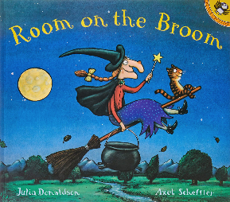  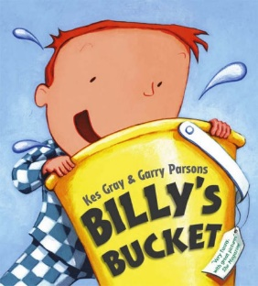  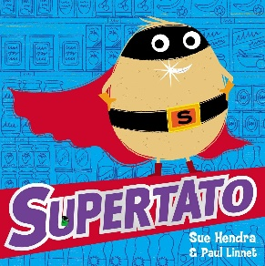  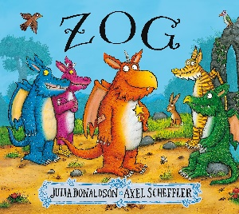
 | WORD READING  Read some letter groups that each represent one sound and say sounds for them.  Read simple phrases and sentences made up of words with known letter–sound correspondences and, where necessary, a few exception words. | Re-read books to build up their confidence in word reading, their fluency and their understanding and enjoyment. Read books consistent with their phonic knowledge.
 | WRITING  Writing:  Form most lower-case letters correctly, starting and finishing in the right place, going the right way round and correctly orientated.  Write labels, short captions and begin to write narratives, which they are able to read back to themselves.  Begin to include finger spaces and some capital letters/ full stops.  Composition:  Orally compose a sentence and hold it in memory before attempting to write it.  Children begin to form narratives in their writing.  Spelling:  Spell words by drawing on knowledge of known grapheme correspondences.  Make phonetically plausible attempts when writing more complex unknown words. | Children engage in writing during continuous provision. They write for their own purposes and enjoyment.
Phonics | 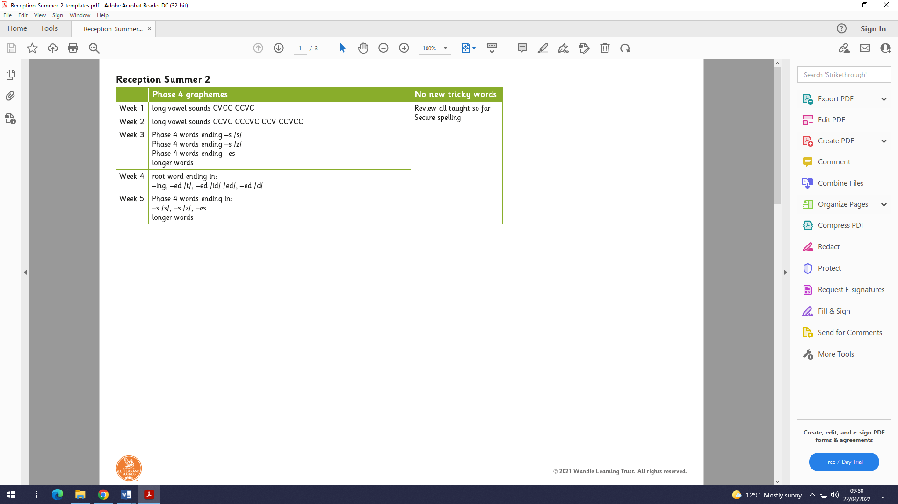  ‘Little Wandle Letters and Sounds’ Phonics programme – https://www.littlewandlelettersandsounds.org.uk/resources/ | 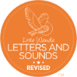  Continue to develop general sound discrimination, rhythm and rhyme, alliteration, voice sounds, oral blending, and segmenting.
Mathematics   | Following the structure of NCtME – Mastering number | 10 frames used to support and compare numbers. Introducing how to make 20 and beyond with 10 frames.  Numerals introduced and children begin to write them. Children begin to recognise patterns in number such as 20-29 having 2 tens.  Informal jottings/drawings to record thinking.  When counting continue to learn that the final number they say names the quantity of the set.  Continue to count, subitise and compare as they explore one more and one less.  Continue to develop understanding that all quantities are composed of smaller quantities. | 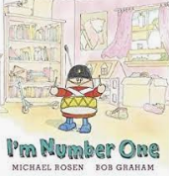  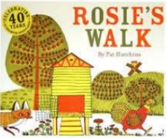  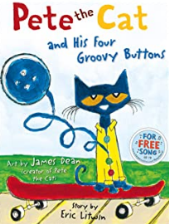
 | 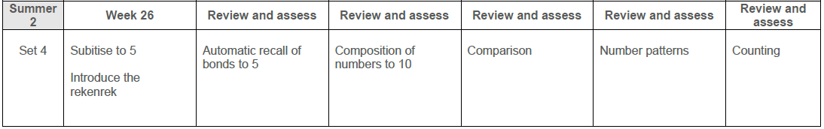
Understanding the World   | Chronology:  Use the language of time when talking about past/present events.  Explore the past through this term’s topics and make comparisons and observations.  Enquiry:  Ask questions, use different sources to find answers including books and the internet (which they know how to use safely.)  Comment on images of familiar situations in the past and compare them to present.  To explore, identify and investigate different places and environments.  Explore important figures in history.  Respect:  Recognise that people have different beliefs and celebrate special times in different ways.  To develop responsibility for our whole environment.  Mapping:  Use technology e.g., a BeeBot and begin to show spatial awareness. Use positional language i.e., under, besides, on top of etc. Use Google Earth to explore the environment in different countries and make comparisons.  Observe, find out about and identify features in the place we live and the natural world and compare them with other places around the world. | Scientific skills –  Comment on what they notice about the environment where they live and draw comparisons between it and other places.  We will ask questions about why things happen and how things work. | Books used to support – See literacy section.  Examples –  ‘Billy’s bucket’.  Features of the seaside, how seaside holidays have changed, finding beaches using ‘Google Earth’.  Books which explore feature of hot and cold places around the world. Exploring habits and their features, animals which live there, finding areas on a map, global warming impact on the environment and the animals etc.
Expressive Arts and Design   | Develop storylines in their pretend play. Use imagination in stories and role play.  Sing in a group or on their own, increasingly matching the pitch and following the melody.  Children are able to select and manipulate art and design resources to create for their own purpose. They can make decisions about what they are doing. Children can edit what they are making and make changes along the way.  Children explore artists work and can comment, saying what they like/ don’t like and why.  Show accuracy and care in their drawing.  Children understand colour and different shades of colour. They are aware of how to mix to produce different colours.  Children can use a variety of collage materials.  Manipulating object such as folding paper to make fans, aeroplanes, books. | Explore, use, and refine a variety of artistic effects to express their ideas and feelings.  Explore and engage in music making and dance, performing solo or in groups.

