
Year 3 Overview of Spring Term
 | Spring 1 | Spring 2 |  |  | Spring 1 | Spring 2
Big question | How do ancient tombs and artefacts help us learn about the past? | Natural Disasters - Can anything good come from a disaster? |  | History | Ancient Egyptians | 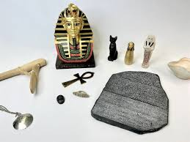  Ancient Egyptians
Visits, visitors and experiences | Class assembly  Egyptian Day and Workshop | World Book Day  Science Week  Egyptian Art Museum |  | Geography |  | Natural Disasters  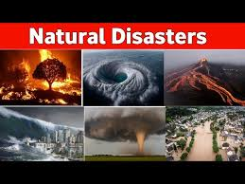
English | 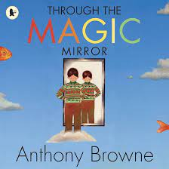  Non-chronological reports  Calligrams & Shape poems | Newspaper Reports  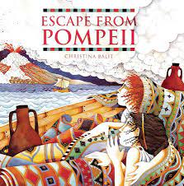 |  | Design and Technology
Whole Class Reading | Freedom Soup  Black Dog  Inside Out | Colours  Walking with my Iguana  The Dark |  | Music | Jazz  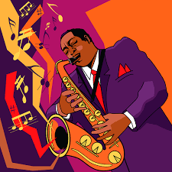
Maths | Multiplication and division | Length and Perimeter  Fractions  Mass and Capacity |  | Art | Egyptian Art  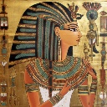 | Famous Artist: Peter Max  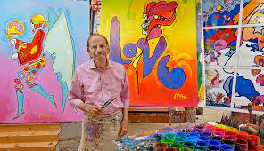
Science | 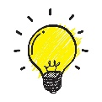  Light | Science Week |  | RE | 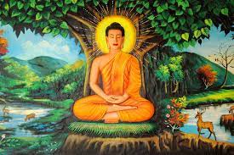  Buddhism | Christianity - Easter
Computing | iNetwork | iData |  | PSHE | Goal setting  Keeping Safe | Rights and Responsibilities
PE | Handball  Ball Skills | Football  Hockey |  | MfL | Playground Games, numbers and age | In a French classroom

