Year 4 Overview of Summer Term
 | Summer 1 | Summer 2 |  |  | Summer 1 | Summer 2
Visits, visitors and experiences | Thames Young Mariners Residential  Hampton Court Trip |  |  | Geography / History | 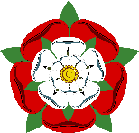  The Tudors | Focus on Brazil: Geography, Climate, Urbanisation, Culture and Traditions
English | Treason  -Debating  -Narrative writing  -Informal Letters  - Diary entries | My Name is River  -Performance poetry  -Persuasive letter  -Narrative writing  - Balanced argument |  | Art/Design and Technology | Sewing Pouches/ Portraits | Printing
Whole Class Reading | 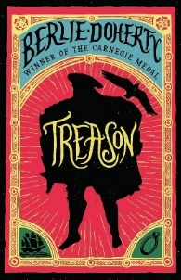 | 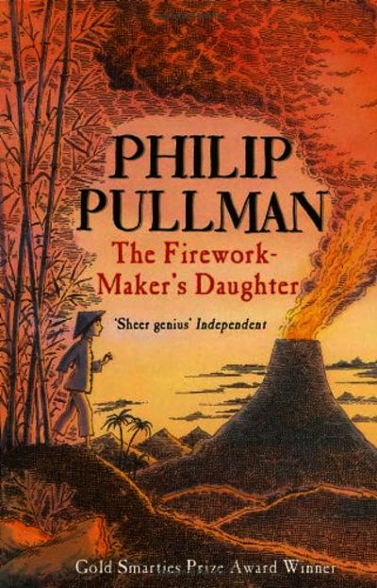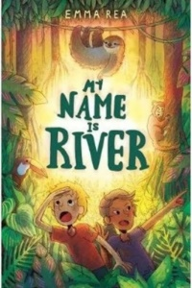 |  |   Music | Body Percussion | Samba and Carnival Sounds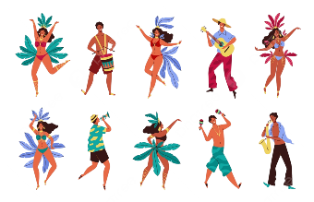
Maths | -Fractions  -Decimals  -Money  -Time | -Shape  -Statistics  -Position and Direction |  | Art | Portraits – Oil Pastels | 
PE | Frisbee / OAA | Sports Day/ Rounders |  | RE |  | Judaism
Computing | Iphoto | Idata |  | PSHE | Wellbeing, Relationships, Identity | Puberty
Science |   Sound | Teeth & Eating |  | MFL  (French) | French food and ordering off a menu

