
Year 1 Overview of Spring Term
 | Spring 1 | Spring 2 |  |  | Spring 1 | Spring 2
Big question | What was it like for children in England during different reigns? | What is it like in each season? |  | History | Queens   | n/a
Visits, visitors and experiences | Kings and Queens day  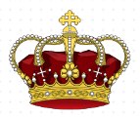 | World Book Day  Science Week     |  | Geography | n/a | Weather
English |   Fairy tales and traditional stories |   Poetry |  | Design and Technology | 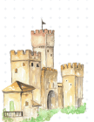  Castles | n/a
Guided Reading  /Phonics | Little Wandle Letters and Sounds | Little Wandle Letters and Sounds |  | Music | Timbre and rhythm patterns (Fairy tales) | Pitch and Tempo – (Superheroes)
Maths | Place Value to 20.  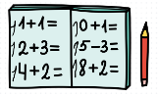  Addition and subtraction with in 20. | Place value to 50.  Measurement- Length and Height. Massa and Volume. |  | Art | n/a | Drawing- Making a mark  Bridget Riley
Science | Materials | Seasonal Change- Working scientifically. 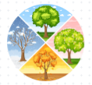 |  | RE |   Hinduism | Sikhism  
Computing | imodel | isafe  iwrite |  | PSHE | Link with wider community- What can we do with money? | Relationships- Who is special to us?
PE | Yoga   | Target games   |  | MfL | 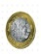  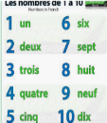  Numbers and days of the week | Weather  