Dear Year One Parents and Carers,

Happy New Year!

We hope that you had a lovely Christmas break. Welcome to the spring term where we look forward to the continuing partnerships between home and school.

Curriculum
Attached to this letter is a curriculum map, which provides an overview of our learning focus for this half term.

Phonics
This term we will be starting Phase 5 sounds please see below. We will be continuing to assess your children every 6 weeks. We will also be recapping phase 3 and 4 and continuing to learn the tricky words and how to spell them.

Reading books and book bags
We have seen a really big improvement with all the children’s reading and understanding of their books. We also have been really pleased to read about all the wonderful home-reading that has been going on since September. The comments in the diary are highly valued by the teachers and they form an important part of your child’s reading journey. Remember to feel free to record home and library books or other reading material that your child has read and enjoyed. Please continue to read with your children as much as possible at home.

School Uniform and P.E Kits
Please ensure that your child is coming to school in the correct uniform that is clearly labelled. This is particularly important when they take off their jumpers as they can often get muddled or mislaid. PE hoodie’s, joggers and trainers should only be worn on PE days. Please also, try to avoid lace up trainers if your child is unable to tie them.

Year 1 P.E days are Tuesdays and Thursdays

Updates and reminders
Morning Routine – School gates open at 8.35am and registration will be taken at 8.45am.

Snacks – We ask that any snack you send in is a piece of fruit or vegetable. There will also be some fruit provided in class for your child.

Medication – Please can you update the class teacher and school office of any changes to your child’s medical needs.

Numbots – Your child’s login will be sent out shortly. They should use the Numbots website at home to support their maths learning.

Seesaw – Our weekly newsletter is uploaded every Friday onto Seesaw for you to read about what Year 1 are learning about the following week. If you are not yet connected to Seesaw then please speak to the class teacher.

Library books- Please ensure children bring them in every Tuesday to be changed.

Dates
During January we have a Queens and Kings day where the children dress up and take part in a workshop. This is on Monday 13th January.

Monday 15th January – Queens and Kings day
Thursday 6th March – World Book Day
Week 10th -14th March - Science Week
Monday 24th and Thursday 27th - Parent Teacher meetings

Thank you in advance for all of your support in the year ahead.

Kind regards,

Miss Smith and the Year 1 team.

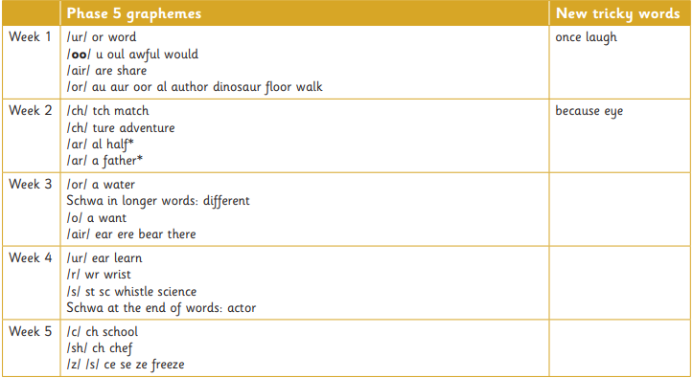
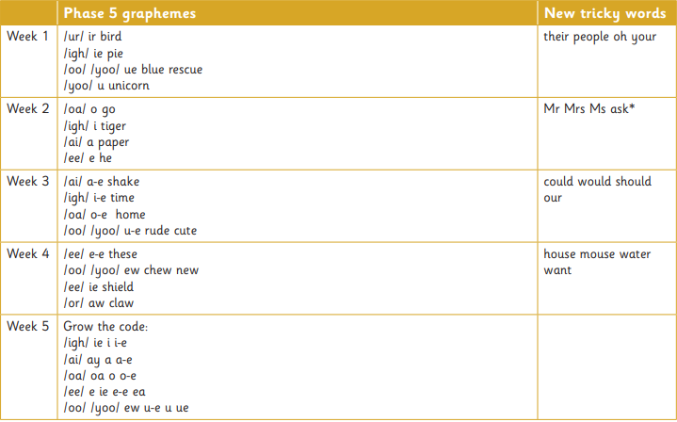
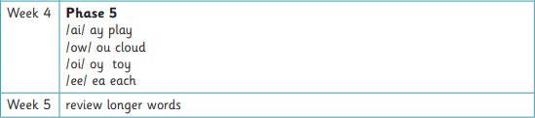
The sounds we will be covering this term in phonics.

The Maths progression we will be covering this term
