Where are we going and how will we get there? Adventure, both real and imaginary.
Prime Areas

Area of learning | Objectives/skills | Revisit/ongoing  throughout the year | Suggested texts, songs and rhymes
Communication and Language   | Listening:  Listen in familiar and new situations.  Engage in stories that are familiar and new with interest and enjoyment.  Attention:  Maintain attention in new situations e.g., whole school assembly or PE sessions in the hall.  Shift attention when required e.g., when given a clear prompt - ‘name’.  Respond:  Make relevant comments when listening to a story and can answer ‘why’ questions.  Link events in a story to their own experiences.  Ask questions to find out more and to check they understand what has been said to them.  Respond to others appropriately in play.  Engage in story times.  Engage in non-fiction book.  Understanding:  Follow instructions or a question with 2 or more parts.  Speaking:  Use intonation to make meaning clear to others.  Start a conversation with peers and familiar adults and continue it for many turns.  Use simple conjunctions in talk to link thoughts ‘and’ ‘because’.  Retell a simple event e.g., how scratched knee’ Recognise words that rhyme or sound similar E.g., “Cat and hat”.  Develop social phrases – “Good morning, how are you?” | Learn new vocabulary Use new vocabulary in different contexts.  Use new vocabulary through the day in discussions and conversations.  Learn new rhymes, poems, and songs.  Listen to and talk about stories to build familiarity and understanding. | Children use the core books to develop language.  (see literacy section)
Personal, Social  and Emotional Development   | Express feelings:  Can show concern for others and show awareness of how their actions may impact on others.  Talk with others to solve conflicts.  Can identify how they are feeling on the zone of regulation board.  Beginning to express their feelings and consider the perspectives of others.  Manage behaviour:  Can take turns and share resources.  Can usually tolerate delay when needs are not immediately met.  Self-awareness:  Can talk about what they are doing and why.  Independence:  Can independently choose areas they would like to play in or resources they would like to use.  Can say when they need help.  Children can independently put on coats and shoes.  Can follow instructions with 2 or more parts.  Collaboration:  Share and take turns.  Children can organise their activity in a group with some independence.  Social skills:  Continue to build constructive and respectful relationships.  Seek familiar adults and peers to engage in conversations and ask for help.  Consider others views and perspectives.  Children are able to manage change in routine and environment in preparation for transition into Year 1. | Continue to develop skills of using gestures, non-verbal communication, facial expressions, body language, appropriate language, and vocabulary; to listen to others, speak to peers and adults and engage in discussions in a positive way.  Introduction of zones of regulation  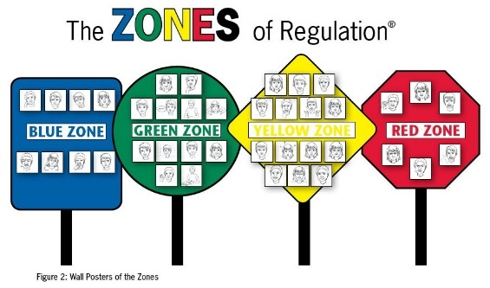 | Children use the core books to explore different aspects of the world. (see literacy section)  E.g., Right and wrong, keeping safe, teamwork, perseverance, awareness of others, reaching a goal, consequences.

Physical  Development   | Children can manage the school day successfully: lining up and queuing, transitions, mealtimes, personal hygiene.  They can use a range of tools competently, safely, and confidently. Suggested tools: pencils for drawing and writing, paintbrushes, scissors, knives, forks, and spoon.  Gross motor skills – A-Frame (climbing), Leisure Area (core strength), weekly PE lessons, tires and large blocks for lifting. | Continue to develop overall body-strength, balance, co-ordination, and agility through use of outdoor play equipment.  Develop fine motor to show increasing control when using a pencil.  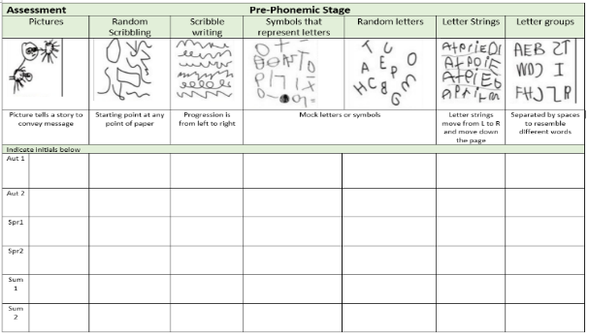
Develop the overall body strength, co-ordination, balance, and agility needed to engage successfully with future physical education sessions and other physical disciplines including dance, gymnastics and athletics.
Revise and refine the fundamental movement skills they have already acquired: rolling, crawling, walking, jumping, running, hopping, skipping, climbing.
Specific Areas
Literacy   | COMPREHENSION  Experience and respond to different types of books, e.g., story books, factual/real-world books, rhyming and non-rhyming stories, realistic and fantasy stories.  Respond to ‘who’, ‘where’ ‘what’ and ‘when’ questions linked to text and illustrations.  Make simple inferences to answer yes/no questions about characters' emotions in a familiar picture book read aloud to them.  Sequence two events from a familiar story, using puppets, pictures from book or role-play.  Begin to read with some prosody (expression) | Daily story time. | 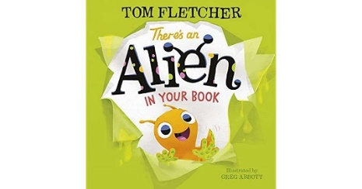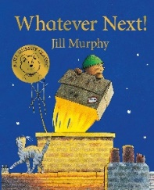  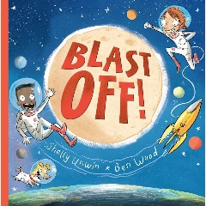  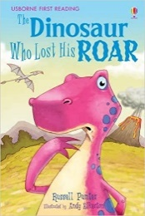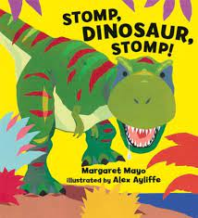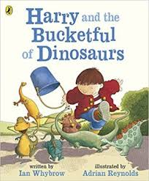  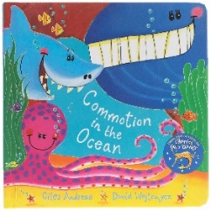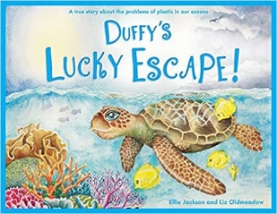  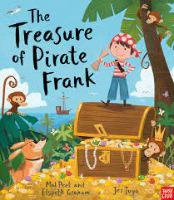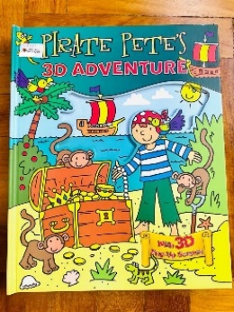
 | WORD READING  Read individual letters by saying the sounds for them.  Blend sounds into words, so that they can read short words made up of known letter-sound correspondences.  Begin to read simple sentences with increasing fluency (including re-reading).  Read a few common exception words matched to our phonic programme.  Begin to recognise some familiar words by sight (in, it) to develop fluency. | Re-read books to build up their confidence in word reading, their fluency and their understanding and enjoyment. Read books consistent with their phonic knowledge.
 | WRITING  Writing:  Use some recognisable letters.  Write letters and strings, sometimes in clusters like words.  Write labels, short captions and begin to write narratives.  Begin to include finger spaces and some capital letters/ full stops.  Composition:  Orally compose a sentence and hold it in memory before attempting to write it.  Children begin to form narratives in their writing.  Spelling:  Write longer words spelling them phonetically. Can spell some tricky words correctly.  Helicopter stories progression:  Adults are dictated to by the child, the adult says each word as it is written, pointing out gaps and punctuation.  Re-reading and scanning and checking writing. Child begins to write the initial sound of a word and the adult continues to write the other parts of the story. | Children engage in writing during continuous provision. They write for their own purposes.
Phonics | 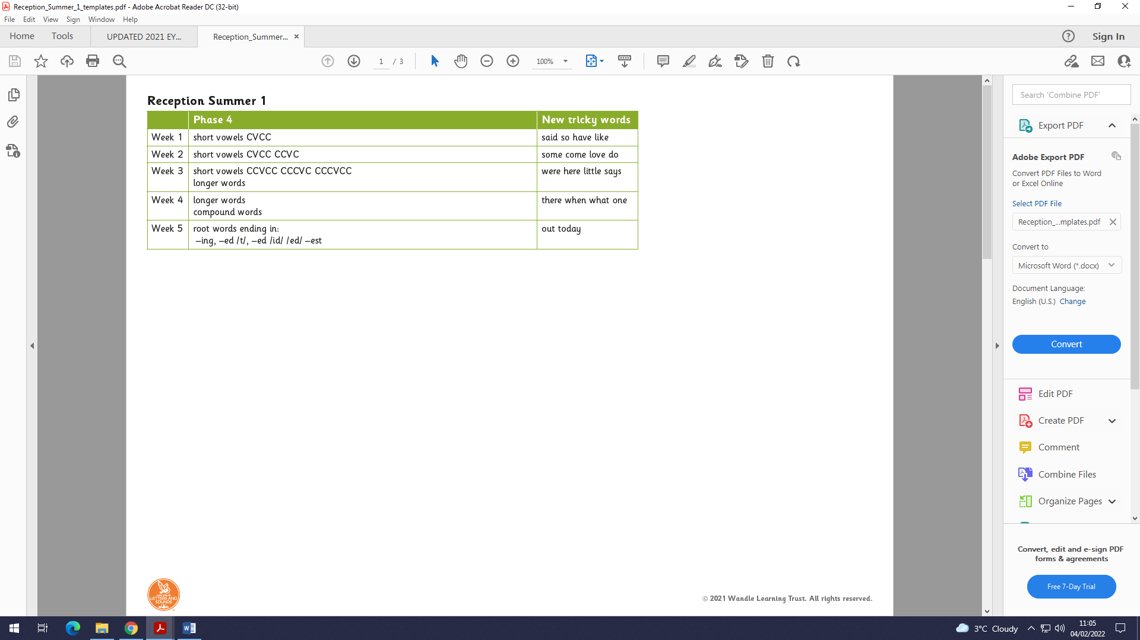  ‘Little Wandle Letters and Sounds’ Phonics programme – https://www.littlewandlelettersandsounds.org.uk/resources/ | 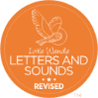  Continue to develop general sound discrimination, rhythm and rhyme, alliteration, voice sounds, oral blending, and segmenting.
Mathematics   | Following the structure of NCETM – Mastering Number | Develop confidence in using manipulatives, graphical representations, subitising and exploring pattern.  Counting real life objects, subitising and counting objects that are identical before moving onto objects with slight differences such as size or colour.  Children encouraged to put objects into a line when counting so there is a clear start and end point.  10 frames used to support and compare numbers. Introducing how to make 20 and beyond with 10 frames.  Numerals introduced and children begin to write them. Children begin to recognise patterns in number such as 20-29 having 2 tens.  Informal jottings/drawings to record thinking.  When counting continue to learn that the final number they say names the quantity of the set.  Continue to count, subitise and compare as they explore one more and one less. | 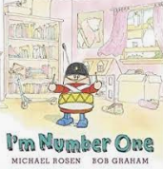  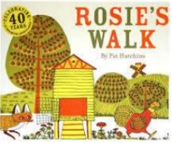  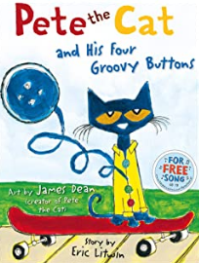
 | 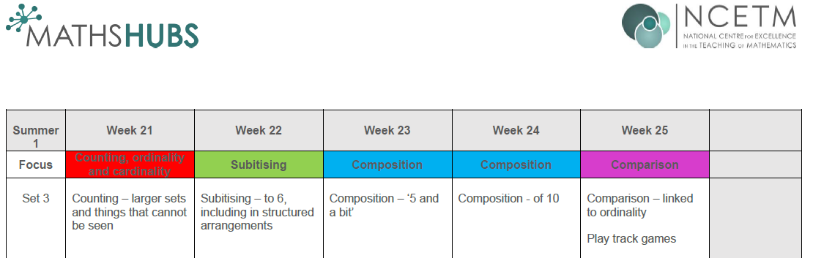
Understanding the World   | Chronology:  Use the language of time when talking about past/present events.  Explore the past through topics such as dinosaurs and space.  Enquiry:  Ask questions, use different sources to find answers including books.  Comment on images of familiar situations in the past and compare them to present.  To explore, identify and investigate different places and environments.  Explore important figures in history such as astronauts.  Respect:  Recognise that people have different beliefs and celebrate special times in different ways.  To develop responsibility for our whole environment, including people, plants and animals.  Mapping:  Use technology e.g., a BeeBot and begin to show spatial awareness. Use positional language i.e., under, besides, on top of etc. Use Google Earth to explore the environment in different countries.  Exploring the difference between season around the world and in other countries and how the seasons effect what grows.  Observe, find out about and identify features in the place we live and the natural world. | Scientific skills –  Comment on what they notice about the environment where they live and understand the effect of the changing seasons on the natural world around them. Describe what they see, hear, and feel outside.  Investigate objects and materials by using all of our senses. We will ask questions about why things happen and how things work. | Books used to support – See literacy section.
Expressive Arts and Design   | Develop storylines in their pretend play.  Sing in a group or on their own, increasingly matching the pitch and following the melody.  Children are able to select and manipulate art and design resources to create for their own purpose. They can make decisions about what they are doing.  Children explore artists work and can comment, saying what they like/ don’t like and why. | Explore, use, and refine a variety of artistic effects to express their ideas and feelings.  Explore and engage in music making and dance, performing solo or in groups.

