
Reception Overview of Autumn Term
 | Autumn 1 | Autumn 2 |  |  | Autumn 1 | Autumn 2
Themes | Settling in and All about me  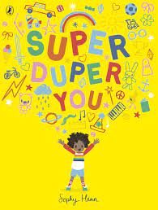  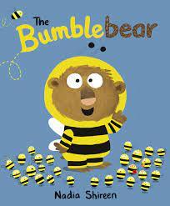  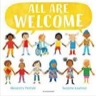 | 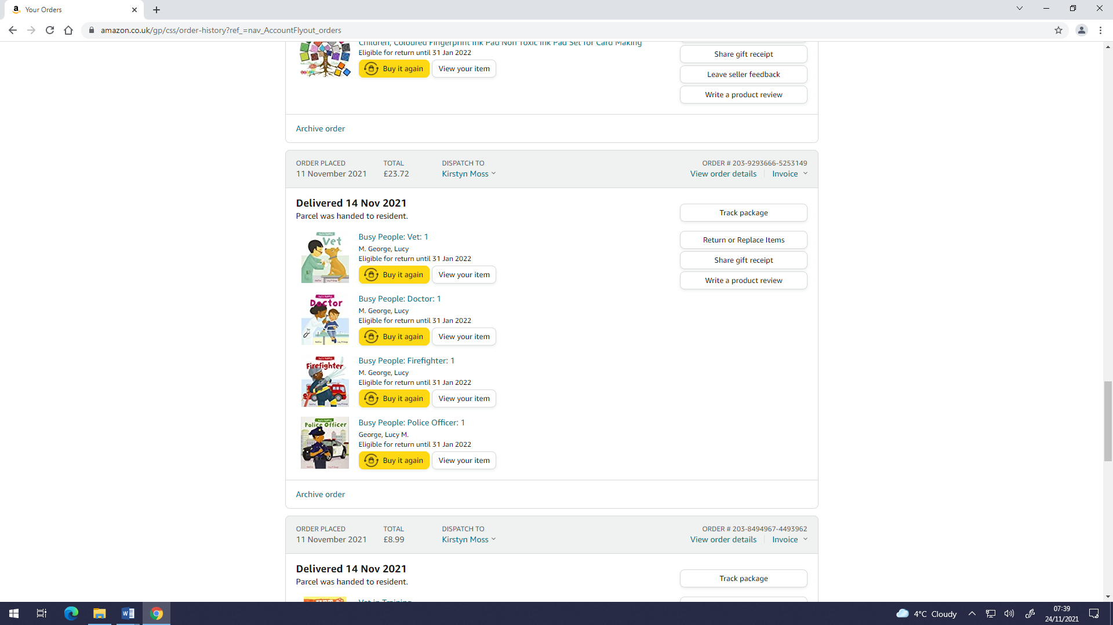  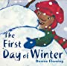  People who help us |  | Understanding the world | Talk about members of their immediate family and those who are family to them.  Talk about and describe features of their own family, talk about families in other countries across the world.  Talk about the features of their immediate environment | Use the language of time when talking about past/present events in their own lives.  Find out about key historical events and why and how we celebrate today?  Recognise that people have different beliefs and celebrate special times in different ways.  Explore seasonal changes.
Literacy  (Including fine motor control) | Core Literacy text – Stanley Stick  Core Nursery rhymes – Star light, star bright and The wheels on the bus.  Core poem – Leaves are Falling  Name writing practice  Makes marks and drawings using increasing control.  Begin to hold a pencil and other tools correctly  Listen and enjoy sharing a range of books.  Learn new vocabulary  Child begins to write the initial sound of a word | Core Literacy text – Think big!  Core Nursery rhymes – Incy wincy spider and row, row, row your boat.  Core poem – A little seed  Letter formation practice  Know that print carries meaning and in English, is read from left to right and top to bottom.  Use new vocabulary in different contexts.  Experience and respond to different types of books  Read individual letters by saying the sounds for them  Beginning to read and write some CVC words. |  | Expressive Arts and Design | Develop storylines in their pretend play.  Self-portrait skills.  Learn simple songs like  1, 2, 3, 4, 5, Once I Caught a Fish Alive  This Old Man  Five Little Ducks | Sing in a group or on their own, increasingly matching the pitch and following the melody.  Explore colour mixing.
 |  |  |  | Personal, Social  and Emotional Development | Aware of own feelings, can talk about feelings using words like ‘happy’, ‘sad’, ‘angry’.  Begin to understand how others might be feeling.  Engage in positive interactions with adults and peers.  Show interested in others play and starting to join in. | Can show concern for others and show awareness of how their actions may impact on others.  Begin to take turns and share resources.
Phonics | Little Wandle Letters and Sounds | Little Wandle Letters and Sounds |  | Communication and Language | Listen to others 1:1, in small groups and whole class.  Begin to use sentences of 4-6 words.  Maintain attention in whole class and small group contexts for a short time. | Listen in familiar and new situations.  Engage in stories that are familiar and new with interest and enjoyment.  Follow instructions or a question with 2 parts in familiar situations.
Maths | 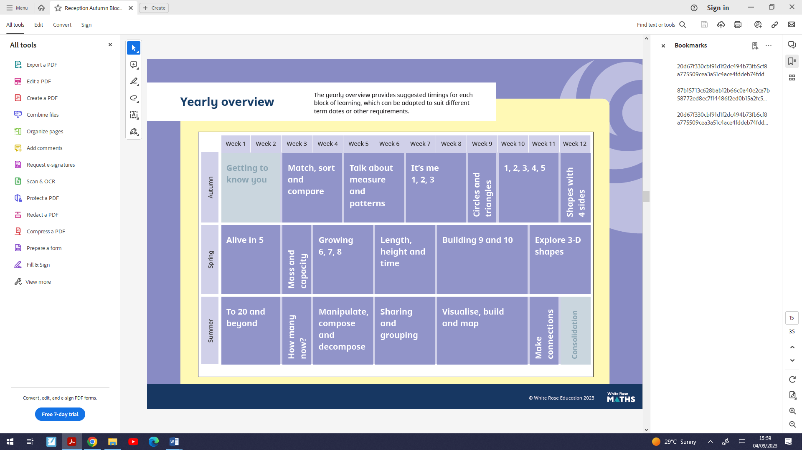 |  |  | Physical development (PE) | Fundamental skills: skipping, jumping and balancing  Team Building  Ball skills  Dance | Develop the overall body strength, co-ordination, balance, and agility

