
Year 3 Overview of Summer Term
 | Summer 1 | Summer 2 |  |  | Summer 1 | Summer 2
Big question | How did the Roman Empire grow and what was their impact on Britain? | How is our local area unique? |  | History | The Romans
Visits, visitors and experiences | Roman Day |  |  | Geography |  | Whitton and Beyond
English | Non-chronological report  The Promise  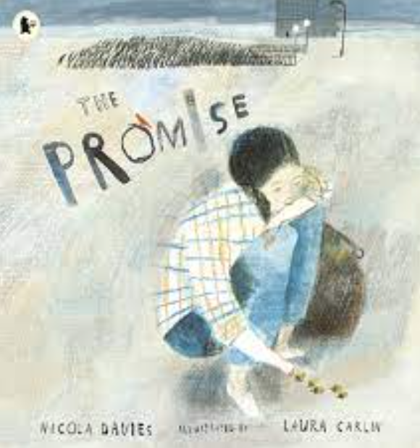 | Myths and Legends  Moon Man  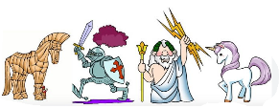  Performance Poetry  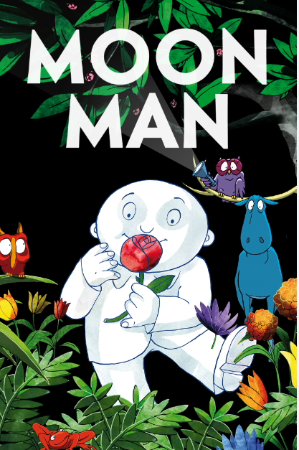 |  | Design and Technology |  | Textiles: Egyptian Collars  Cooking  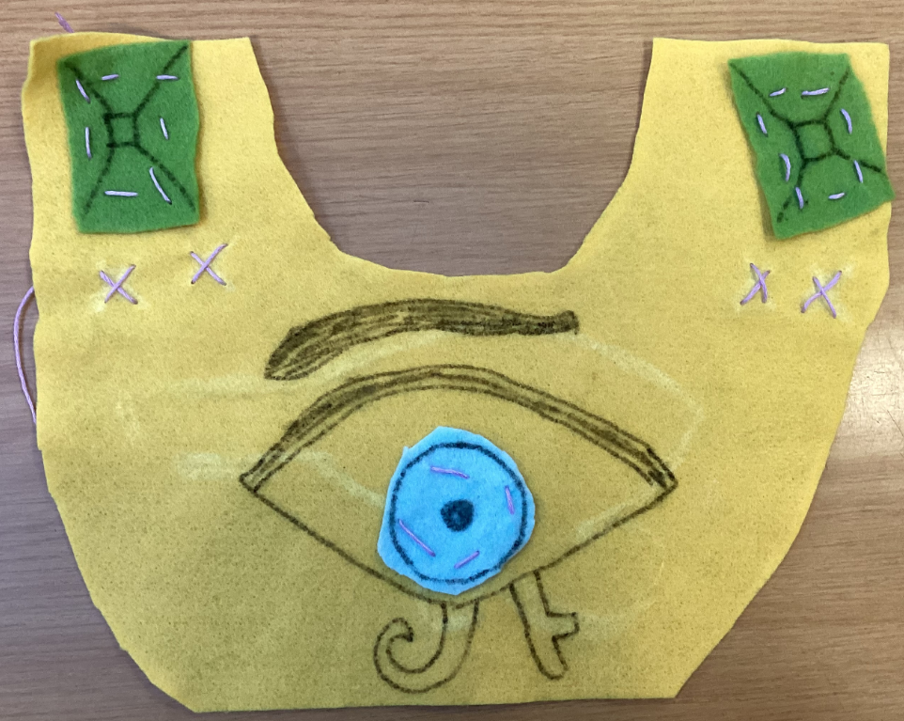
Whole Class Reading | 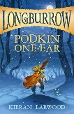  Podkin One Ear | 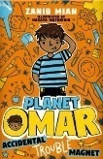  Planet Omar: Accidental Trouble Magnet |  | Music | Adapting and transposing motifs – Theme: The Romans
Maths | Fractions  Money | Time  Shape  Statistics |  | Art | 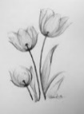  Growing Artists: Drawing and shading
Science | Plants | Animals including Humans |  | RE | Sikhism | Christianity
Computing | iConnect -  The Internet and World Wide Web | iPodcast -  Creating and editing audio podcasts |  | PSHE | Money and Budgeting | Healthy Lifestyles  RSE
PE | Golf  Tennis | Sports Day Training  Cricket |  | MfL | French transport | French animals and their habitats

