The sounds we will be covering this term in phonics.
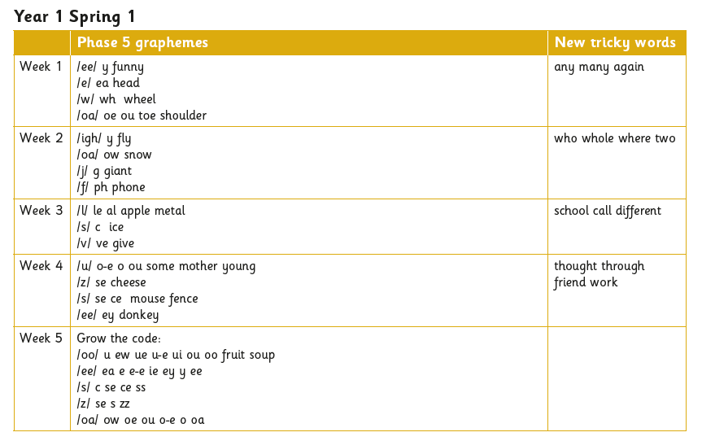
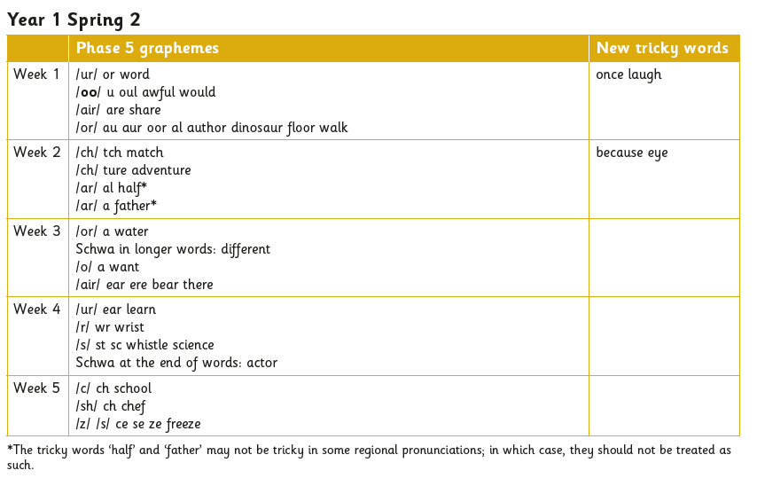
The Maths progression we will be covering this term 