
Year 5 Overview of Summer Term
 | Summer 1 | Summer 2 |  |  | Summer 1 | Summer 2
 |  |  |  | History
Visits, visitors and experiences | Ancient Greece Workshop  Class Assembly 5S | Class Assembly  Arts Week  Sports Day |  | Geography | Greece | Compare the UK, Greece and North America.
English | 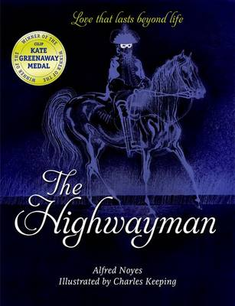 | 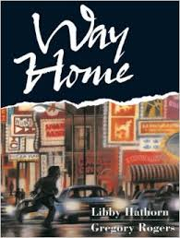  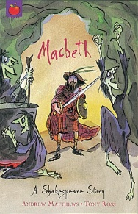 |  | Design and Technology | Stuffed Toys | Food – Making bread
Whole Class Reading | 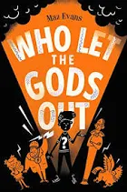 | To be confirmed |  | Music | Looping and remixing | Musical theatre
Maths | Shape  Position and Direction  Decimals | Negative numbers  Converting units  Volume |  | Art | DT focus | Drawing – Being an architect
Science | Living things and their habitats | Animals including humans |  | RE | Sikhism
Computing | iProgramme | iModel  iSafe |  | PSHE | What makes up a person’s identity? | RSE - Puberty
PE | Tag Rugby  Sports Day Training | Cricket  Tennis |  | MfL | Meet the Family | Verbs in a French week

