
Year 1 Overview of Summer Term
 | Summer 1 | Summer 2 |  |  | Summer 1 | Summer 2
Big question | Where in the world are we? | How has the seaside changed over the years? |  | History | n/a | Seaside in the past  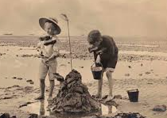
Visits, visitors and experiences | Painshill Park trip | Arts week |  | Geography | Continents and Oceans  Where do we live?  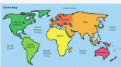 | n/a
English | 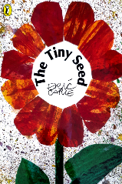 | 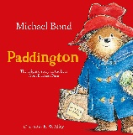  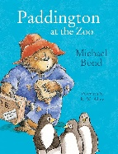  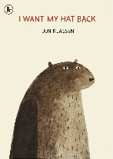 |  | Design and Technology | Textiles  Making puppets  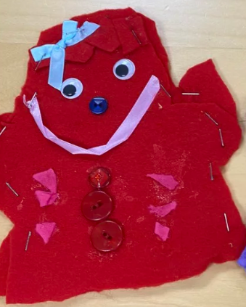 | n/a
Phonics | Little Wandle Phase 5 Spring 1 and 2 | Little Wandle Phase 5 Spring 2 and Summer |  | Music | Under the sea  (Musical Vocabulary) | By the sea  (vocal and body sounds)
Maths | Multiplication and division(2, 5, 10)  Fractions (1/2 and 1/4)  Position and direction | Place Value to 100  Time  Money |  | Art | n/a | Sculpture and Collage  Arts week 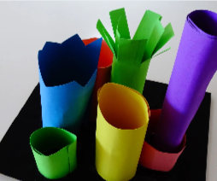
Science | Soil, seeds and sunshine  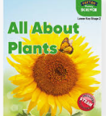 | Working scientifically   |  | RE | Humanism   | n/a
Computing | iprogram1   | Iprogram2   |  | PSHE | Wellbeing, Relationships and Identity | What is the same and different about us?
PE | Athletics | Sports day preparation |  | MfL | Colours | Food

