Monday 13th January 2025

Dear Year Two Parents and Carers,

Happy New Year!

We hope that you have all had a relaxing holiday and are now ready for the challenges of the Spring Term in Year Two. Thank you for all your support at home last term supporting your child with practicing their spellings. This term we are going to enjoy learning all about our new topics: Polar Explorers and Space Cadets. Below you will find information about the curriculum this term, some general information and useful dates for your diary.

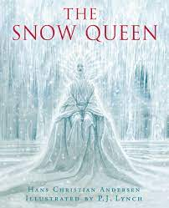
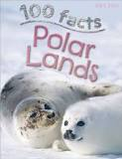
Reading
Our goal is to create confident, fluent, independent readers. In Year 2 we will be reading The Snow Queen to support our English teaching as well as researching information books about the Polar Regions. Using VIPERS we will continue to focus on word reading to develop fluency, prosody and comprehension skills. VIPERS stands for: vocabulary, infer, predict, explain, retrieve and sequence/summarise. Please continue to share a story together, encouraging your child to talk about what is happening in the pictures, asking questions and predicting what might happen next. If you feel you would like more information about books suitable for Year 2 children, feel free to talk to your class teacher who can provide you with some guidance. (See Below)

Curriculum
Attached to this letter is a curriculum map, which provides an overview of our learning focus for this half term. Our writing focus in English will be information texts and The Snow Queen will be used to continue to develop the children’s creative writing. Further on in the term we will be developing the children’s skills to research and write information texts as we explore the Polar Lands in Geography and habitats in science. In maths, we will be looking at shapes and their properties, extending the children’s knowledge to calculate multiplication and division as well as continuing to consolidate their understanding of addition and subtraction while using money. In PE the children will be developing their movement and balancing skills through fitness and yoga lessons.

Homework
Spelling Bookmarks- The spelling bookmarks will be continuing this half term and will be given out on a Friday ready for their quiz the following Wednesday. Each bookmark has key words to learn as well as the spelling pattern to learn. Towards the end of January, the bookmark will start to include an arithmetic quiz. This is a fun activity to encourage your child to calculate number sentences and even develop a challenge where they can time themselves to see how quickly they can work out the answers!

In the coming weeks your child will have the Spring Term Home Learning grid. This continues the school’s policy for home learning by giving the children a variety of different activities for them to complete during the term. They can choose to do any or all of the tasks, at any time, during the spring term. The decision as to which home learning tasks are completed and when, can be discussed between you and your child. The children do not have to do a set number of tasks nor is there a time limit for doing each one. Your child can then share their work with the class and it will be added to the classroom display. Whilst these activities are not a requirement, they are designed to complement and enrich the children’s learning that has taken place in the classroom.

School Uniform and P.E Kits
Please ensure that your child is wearing the appropriate track suit/leggings and their school PE top. On the class PE days children should continue to come to school in their PE kit and wear suitable shoes for PE. It is good practice to make sure all uniform and P.E kit is clearly labelled. This is particularly important for jumpers/cardigans as various items of clothing often get muddled up or mislaid!

2M PE Days – Tuesday and Thursday
2L PE Days – Tuesday and Thursday

OPAL Playtimes
Please can we remind you to provide a pair of wellington boots or spare shoes for your child to wear when they decide to go onto the field during playtimes.

Updates and reminders
Morning Routine – Children come into class from 8:40am ready for the day’s learning.
Snacks – We ask that any snack you send in for break time is a piece of fruit or vegetable. There will also be some fruit provided in class for your child.
Medication – Please can you update the class teacher and school office of any changes to your child’s medication needs.

Key Dates - We very much hope to have:

Friday 7th February 2L Cake Sale 3:10pm
Thursday 6th March 2025 – World Book Day
Thursday 13th March 2025 - Science Trip to Winchester Science Centre
Friday 14th March 2025 – 2M Cake Sale 3:10pm
Monday 24th March – Parent/Teacher meeting
Thursday 27th March – Parent/Teacher meeting
Friday 4th April 2M Assembly 9:30am

We will continue to do our very best to ensure that these dates will go ahead as planned. However, please be aware that things may change at short notice. We appreciate your understanding and continued support.

If you have not already done so and have the time, we would welcome volunteers to help supervise the children on our school trip to the Winchester Science Centre. Please contact the office who can advise you of the necessary documentation required.

Many thanks for all of your support,
The Year 2 Team

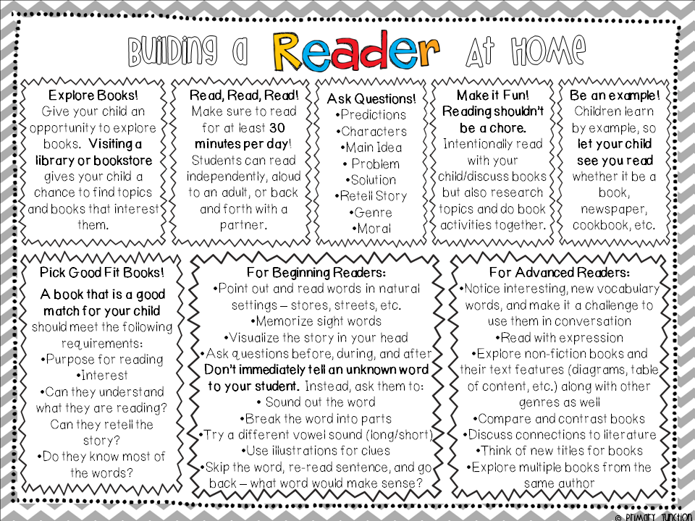

Year 2 Spring 1 and 2 Polar Explorers and Space Cadets
 |  | Successful Learners
 |  | Areas of learning
As geographers we will investigate different environments and landscapes and discover new places different from ours. We will look at different parts of our solar system.
As historians we will find out about early and current space exploration and what people thought about it.
As scientists we will become astronauts. We will look at the Moon, how humans have visited it and then look at survival in space.
We will also learn how to categorise objects into living, dead and never been alive. We will observe and record close-up observations of micro-habitats and ask questions about different habitats.
We then look at sources of food for the animals in different habitats.
As artists we will explore ideas from our imaginations and use colour and texture to create different worlds. We recreated art from different cultures and created art inspired by different habitats.
Responsible Citizens
Environment | Spiritual & Moral |  | Communities
Endangered animals and considering the declining polar lands.  Caring for the natural environment by discussing what can be recycled. | Considering the habitat of animals and our responsibility to them. |  | Interview family or friends to record reactions to the lunar landing.  Consider any parental links to talk about different cultures and environments.
